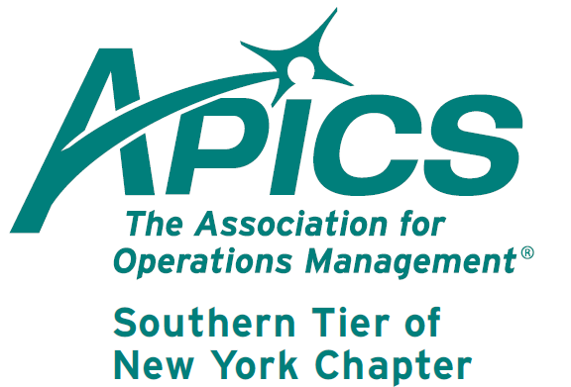
www.stapics.org

NO DINNER MEETING THIS MONTH

Upcoming PDM’s

May 2013 – The True Path to ERP Happiness

Surveys show that 75% of companies that use ERP software solutions feel they have not gotten the benefits they expected. ERP software implementations require huge investments of time and dollars, and much investigation goes into the selection of the proper solution. Why the poor performance and unmet expectations? There is an answer. It requires some serious self-examination and a change in focus. In this session, you will learn how to achieve the improvements you expect and maximize the benefits of your ERP solution.

June 2013 – Member Appreciation Night.

Join us at the ballpark. Details to follow.

APICS Update from Don Sheldon, Director of Education

Raymond Tour – Our friends at the Raymond Corporation factory in Greene, NY have agreed to facilitate a tour for our April meeting. We have several signed up now for the tour. All are welcome! Raymond Corporation is the premier producer of narrow aisle material handling equipment in North America and a division of Toyota since 2001. The tour of the Greene facility will be held on April 17th at 6 PM. There will be no cost for this tour and we expect it to take less than 1 hour. (No meal and meeting in April—the tour takes its place). We hope to have a big group to tour this impressive local world class facility. We will meet at the parking lot near the main entrance at 5:45. The main entrance is on the opposite side of the plant from route 12. Please register with me (dsheldon@sheldoninc.com) as soon as possible.

CPIM – Basics of Supply Chain Management Training – We are in partnership with Broome Community College again to offer a CPIM series on their campus starting in June this summer. The fee is $685 per student for non-APICS members (includes a membership) or $485 APICS for members per module with the first offering being Basics of Supply Chain Management. Contact Broome Community College to register. For a copy of the BCC catalog use this website: https://www.sunybroome.edu/c/document_library/get_file?uuid=0876178a-92b6-438b-9f0d-778658b8f355&groupId=39972

The dates for this BCC Offering are:
28 June 1-5 PM Lessons 1&2
12 July 1-5 PM Lessons 3&4
26 July 1-5 PM Lessons 5&6
9 August 1-5 PM Lessons 7&8
23 August 1-5 PM Lessons 9&10

Again, the price will be $575 plus $110 for the student workbook ($685 total) for a non-APICS member. It is $375 plus $110 the student workbook ($485 total) for APICS members. There will be a minimum class size to run the course. It is our intention to continue on through the CPIM series if there is interest.

If you are interested in any other Southern Tier offerings, please contact me at dsheldon@sheldoninc.com. Thanks!

Thanks!
Don Sheldon
Wed. April 24th

We’re on !!!
Come and visit, poke around, or comment on us! Our name there is “Southern Tier APICS”. It’s just another way
for us to keep in touch with our membership.

Board of Directors 2012-2013

President Director of Publicity
Dave Gardner Kelly Norieka
dave@protofab25.com Kelly.norieka@lmco.com

Executive VP /Director of Finance Director of Education
Steve Whited Don Sheldon
steven.whited@acco.com dsheldon@sheldoninc.com

Secretary Director at Large
Debbie Unkel Steve Stanchak
deb.unkel@raymondcorp.com steve.stanchak@infoprint.com

Director of Membership/Director of Chapter Standards/

Director of Online Publication Director of Student Relations
Lee Schechter Brian Arrnold
lschechter@stny.rr.com barnold@amphenol-aao.com

Director of Programming and Marketing Director of Communications
Michael LoSapio April McWeeney
Michael.LoSapio@SynergyResources.net april.mcweeney@acco.com

Southern Tier APICS
PO Box 1107
Binghamton NY 13902-1107

